Evidence-Based Strategies to Reduce Underage Alcohol Consumption

**Notes:**

* Many good and fairly comprehensive lists of evidence-based strategies to address underage drinking are available online.
* The resource featured here—*Catalog of Environmental Prevention Strategies*, created by the Wyoming Survey & Analysis Center at the University of Wyoming—is an excellent starting point; it covers the most strategies and reviews the most research of any resource we’ve found, and it includes strategies appropriate for higher education settings. However, it represents neither an exhaustive nor a mandated list of strategies.
* Communities should be sure to discuss potential strategies with their TA providers.
* For your reference, we have included the table of contents (which lists the strategies reviewed in this guide) and the guidance pages on how to use the catalogue. The full text of the document can be found [here](http://www.wishschools.org/resources/Catalog%20of%20Environmental%20Prevention%20Strategies_Final4%20Wyoming.pdf).

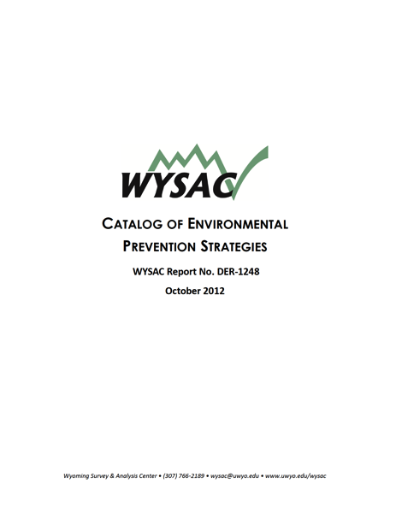

From *Catalog of Environmental Prevention Strategies* by H. Costello, N. M. Nelson, K. Henry, and K. S. Freedman (2012). WYSAC Report DER-1248. Laramie, WY: Wyoming Survey & Analysis Center, University of Wyoming.